# Question 01

## Code

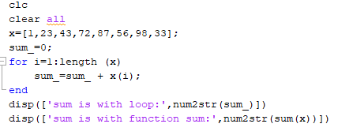

## Output



# Question 04

## Code

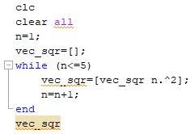

## Output

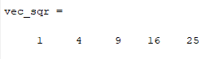

# Question 06

## Code

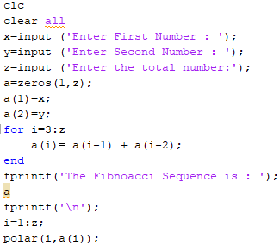

## Output

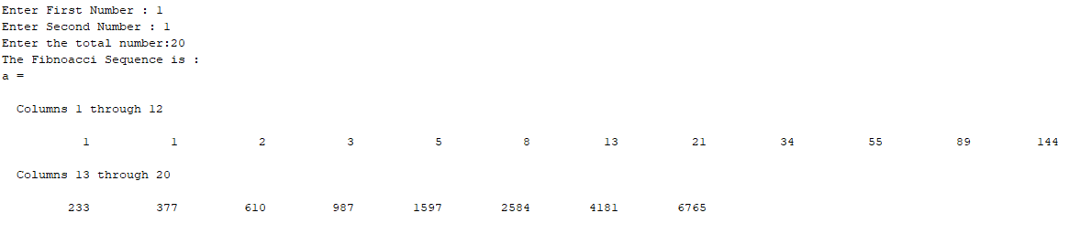

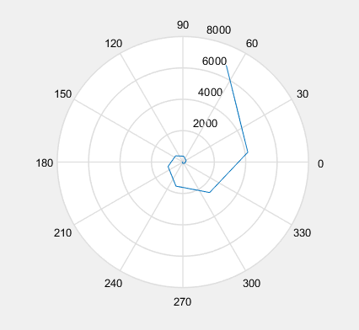

# Question 13

## Code

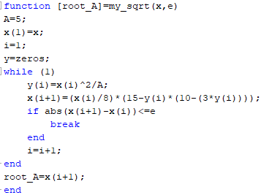

## Output

Find the square root of 5. Initial guess 2 and convergence value is 0.01.

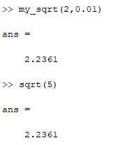

# Question 21

## Code

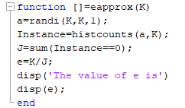

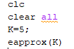

## Output

The output is every time change because we use the randi function which generate the random integer.

